Assignment (N+): OSI Layer
Task-1:
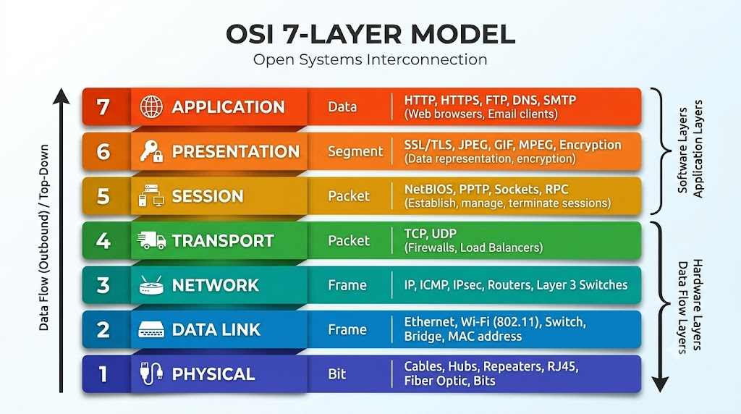

Task-2:
- Encrypting data before sending:
Presentation Layer (Layer 6)
- Routing packets across networks:
Network Layer (Layer 3)
- Converting data to electrical signals:
Physical Layer (Layer 1)
- Opening a web page in your browser:
Application Layer (Layer 7)
- Detecting and correcting errors in frames:
Data Link Layer (Layer 2)

Task-3:
- Let’s talk about Whatsapp
- Application Layer:
When we are open whatsapp that time, Whatsapp generates request and sent request to the Whatsapp server. When server sent response to our device then after Whatsapp open successfully. This process performs in HTTPS protocol.

- Presentation Layer:
This layer works on encryption and data representation. If we talk about whatsapp, when user is using whatsapp, that time what user shows details or interface which is called presentation and it is managed by this layer. In a easy language, this layer converts code in to human visible format.

- Network Layer:
When user want to send massage to other person, for example user types “Hello, How are you?” and press sent button, then after this data packet travel source to destination but before travel that data packet assigned IP address and routed by process and this process performs in network layer.

Task-4:
Session Layer:
If server fails establish session then after possible that pinging is successfully done but website doesn’t open.

Transport layer:
This kind of problem some times happened when ports were blocked by some reason. Ping does not need ports but websites needs port 80(http) or port 443(https).

